An Alternative View of Tables of Isotopes
Aran David Stubbs
Ever since the discovery of the Neutron by Chadwick in 1932, tables of isotopes based on the atomic number z and the neutron count n have been possible. The Italian Georgio Fea got into print in February 1935¹, probably first. Many other lists followed^{2,3,4,5,6}. A common arrangement of the table of Isotopes is the n * z arrangement, with neutron count on 1 axis and proton count on another. This is an obvious, intuitive arrangement. This does have some downsides. While only about 3200^{7,8} isotopes are known, this arrangement requires a 180*120 matrix for the known isotopes. All the known isotopes are in a thin strip along a diagonal. A standard work-around is to slice the table up and display these side by side. This makes it difficult to see long term patterns.
Several alternates exist, some better than the standard and some worse. To judge what are good or bad arrangements, some criteria are needed. The simplest is display area: the number of cells the matrix occupies. Another choice is the size of the longer axis. By the first criteria, the standard form is 21600 cells, by the second its long dimension is 180.
From number theory, a vector with small numbers produces the smallest range of values. Since n has a larger range, differences from n give a good start. The obvious choices are: n, z, n+z, n-z, n-2z, 2n-3z, and 3n-5z. The later two were chosen by virtue of closely following the center of the data. A cross product of any disjoint pair of these vectors produces a possible display space. Some of these pairs yield skew sets, for instance n-z vs n+z where odd in one and even in the other produces an empty product set. So the size of the cross product is half the product of the vectors range (120*300/2 in this case).
Several choices are less than 30% of the display area of the standard form, with the best (n-z * n-2z) using less than 25% of the area. It is also tied for lowest maximum dimension with 74. Here is a table summarizing the available layouts. The data displayed is half life, with dark longest and white shortest. The standard and the best also have links to actual isotope tables.

 | n  0 to 179 | z  0 to 119 | n-z  -8 to +61 | n-2z  -69 to +4 | 2n-3z  -58 to +29 | 3n-5z  -127 to +24
n+z  0 to 299 | 300*180  54,000 cells | 300*120  36,000 cells | 300/2*70  10,500 cells  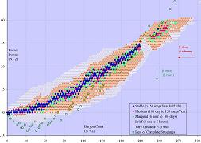 | 300/3*74  7400 cells  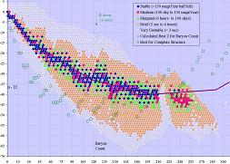 | 300/3*88  8800 cells  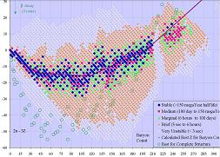 | 300/5*152  9120 cells  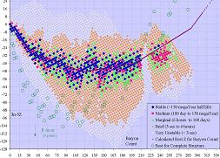
n  0 to 179 | N/A | 180*120  21,600 cells  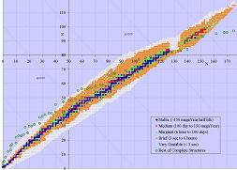 | 180*70  12,600 cells  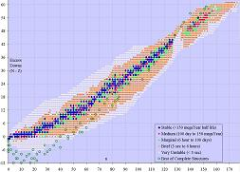 | 180/2*74  6660 cells  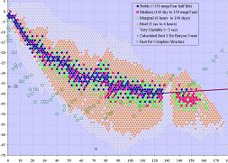 | 180/3*88  5280 cells  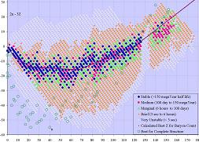 | 180/5*152  5472 cells  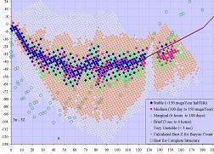
z  0 to 119 | 120*180  21,600 cells | N/A | 120*70  8400 cells  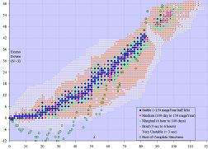 | 120*74  8880 cells  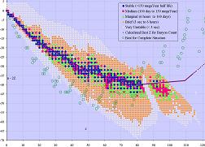 | 120/2*88  5280 cells  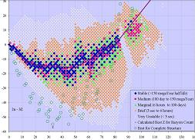 | 120/3*152  6080 cells  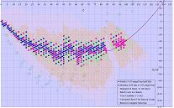
n-z  -8 to +61 | 70*180  12,600 cells | 70*120  8400 cells | N/A | 70*74  5180 cells  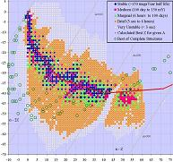 | 70*88  6160 cells  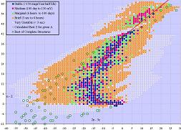 | 70*152/2  5320 cells  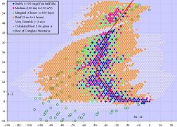
n-2z  -69 to +4 | 74*180/2  6660 cells | 74*120  8880 cells | 74*70  5180 cells | N/A | 74*88  6512 cells  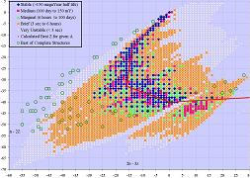 | 74*152  11,248 cells  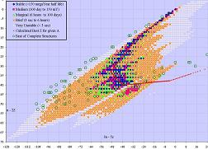
2n-3z  -58 to +29 | 88*180/3  5280 cells | 88*120/2  5280 cells | 88*70  6160 cells | 88*74  6512 cells | N/A | 88*152  13,376 cells  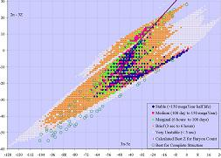

While the n-z by n-2z is clearly best for the known isotopes, it fades a bit for the likely extensions. With z ranging 0:137 and A (n+z) ranging 0:390 (which is likely), n-z ranges -8 to +116, for 9250 cells. The n-2z vs A/3 is the next best for that space with n-2z retaining its -69 to +4 range, and A/3 ranging 0:130, for about 9700 cells. Here is a blowup of the best fit:
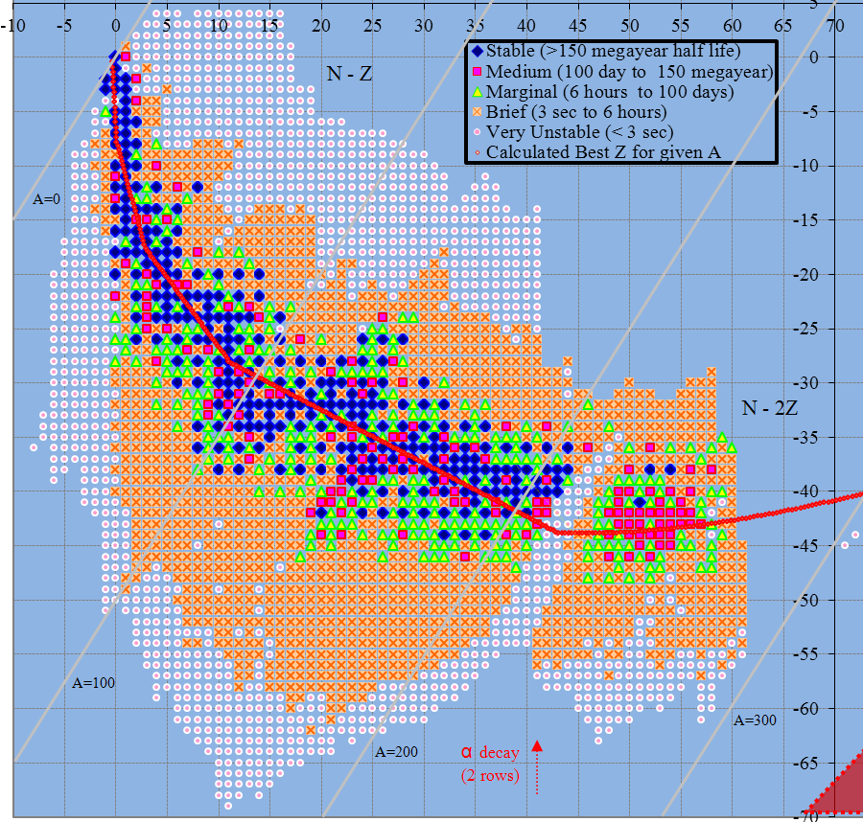
Many of the arrangements may be valuable for a particular use. For instance the energy per baryon looks like this in A/3 * n-2z, and n-z * n-2z, respectively. A blue outline surrounds the cell with the lowest energy per baryon for a baryon count, and green for the stablest when that is not least energy.
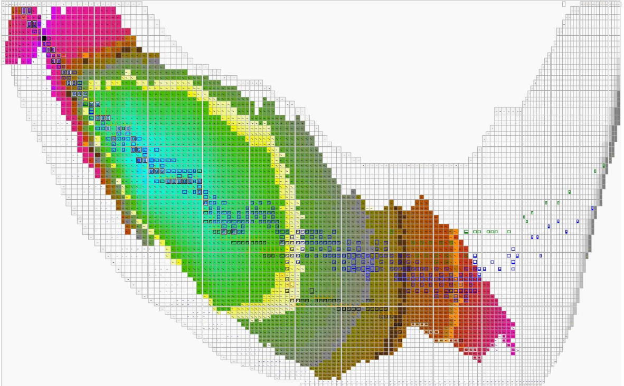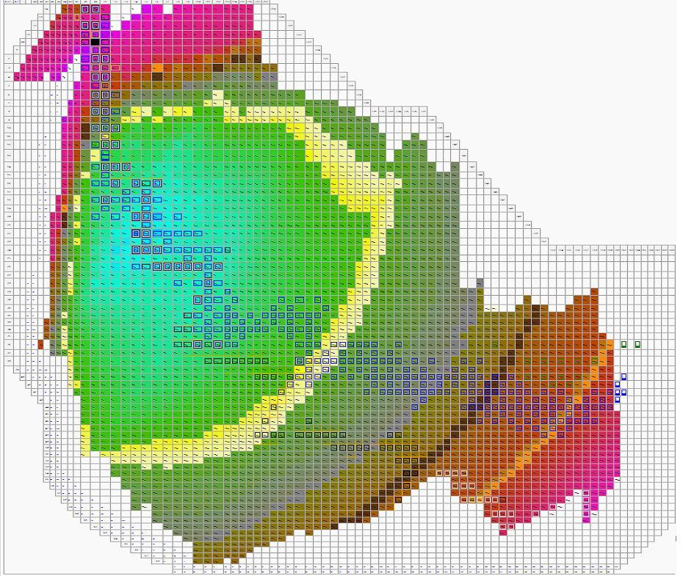

References
- “Tabelle Raissuntive E Bibliografia delle Transmutazioni Artificiali” Georgio Fea. Il Nuovo Cimento 2 (1935) 368
- Amaldi, D'Agostino, Fermi, Pontecorvo, Rasetti, and Segrè, Proc. Roy. Soc. London A149, 522 (1935)
- Alichanian, Alichanow, and Dzelepow, Physik. Zeits. Sowjetunion 10, 78 (1936)
- “Table of Isotopes” G. T. Seaborg and I. Perlman Rev Mod Phys 20 585-667 (1948)
- “Table of Isotopes” Strominger, D. ; Hollander, J.M. ; Seaborg, G.T. Rev Mod Phys 30 585-904 (1958)
- “Table of Isotopes” Browne, E. ; Dairiki, J.M. ; Doebler, R.E. ; Shihab-Eldin, A.A. ; Jardine, L.J. ; Tuli, J.K. ; Buyrn, A.B. book: Stanford press, Fireside, John Wiley & sons (1978) revised (1996)
- "What We Do: The Chart of Nuclides". Knolls Atomic Power Laboratory. http://www.knollslab.com/nuclides.html Retrieved 14 May 2009
- Nudata from Centre de Spectrométrie Nucléaire et de Spectrométrie de Masse CSNSM, IN2P3-CNRS. Retrieved 15 September 2009.
Illustrations:
N x Z
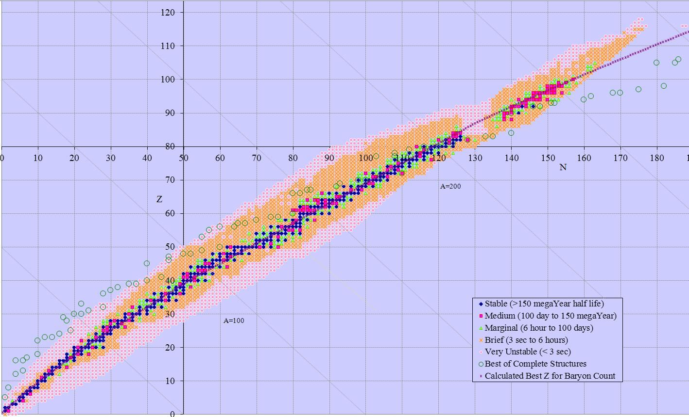

N x N-Z
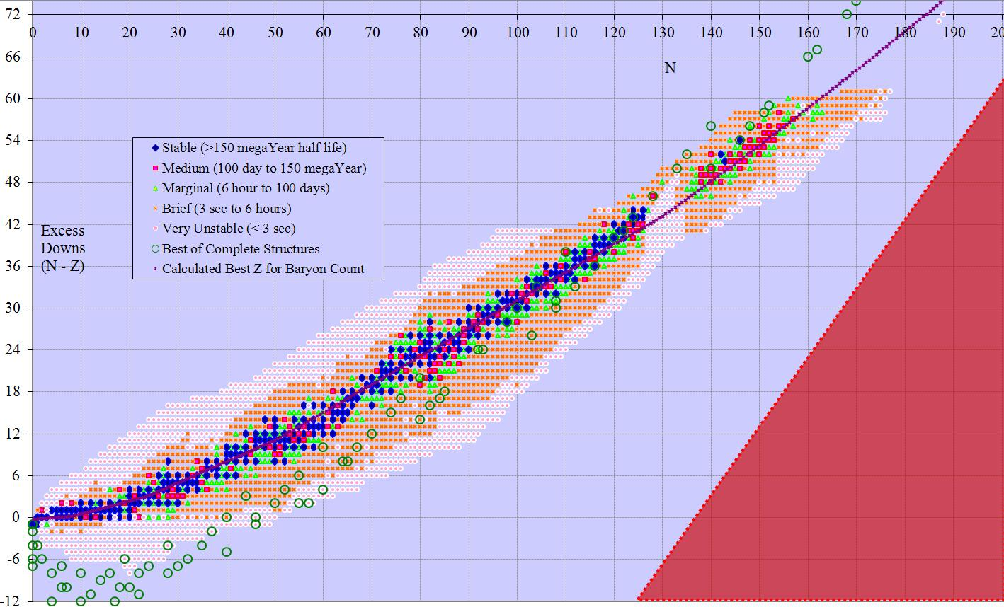

N x N-2Z
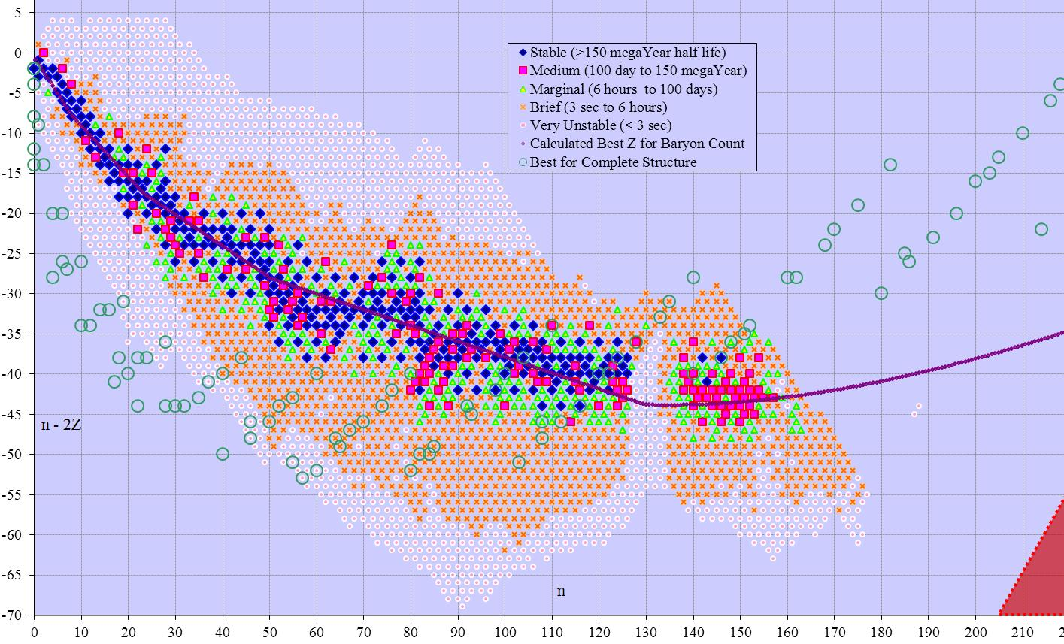

N x 2N-3Z
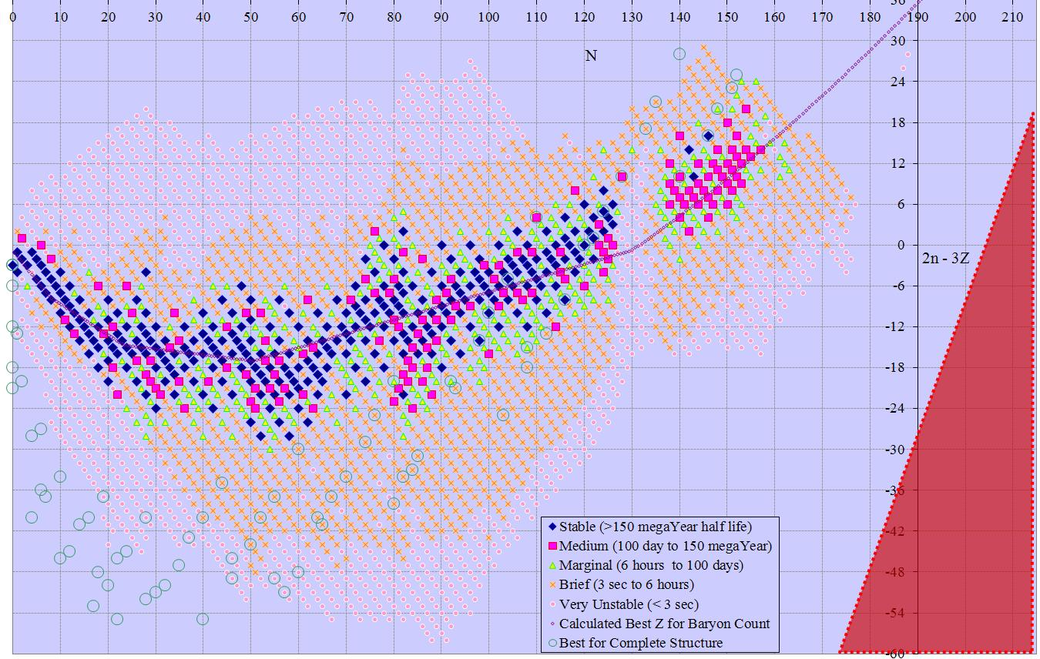

N x 3N-5Z
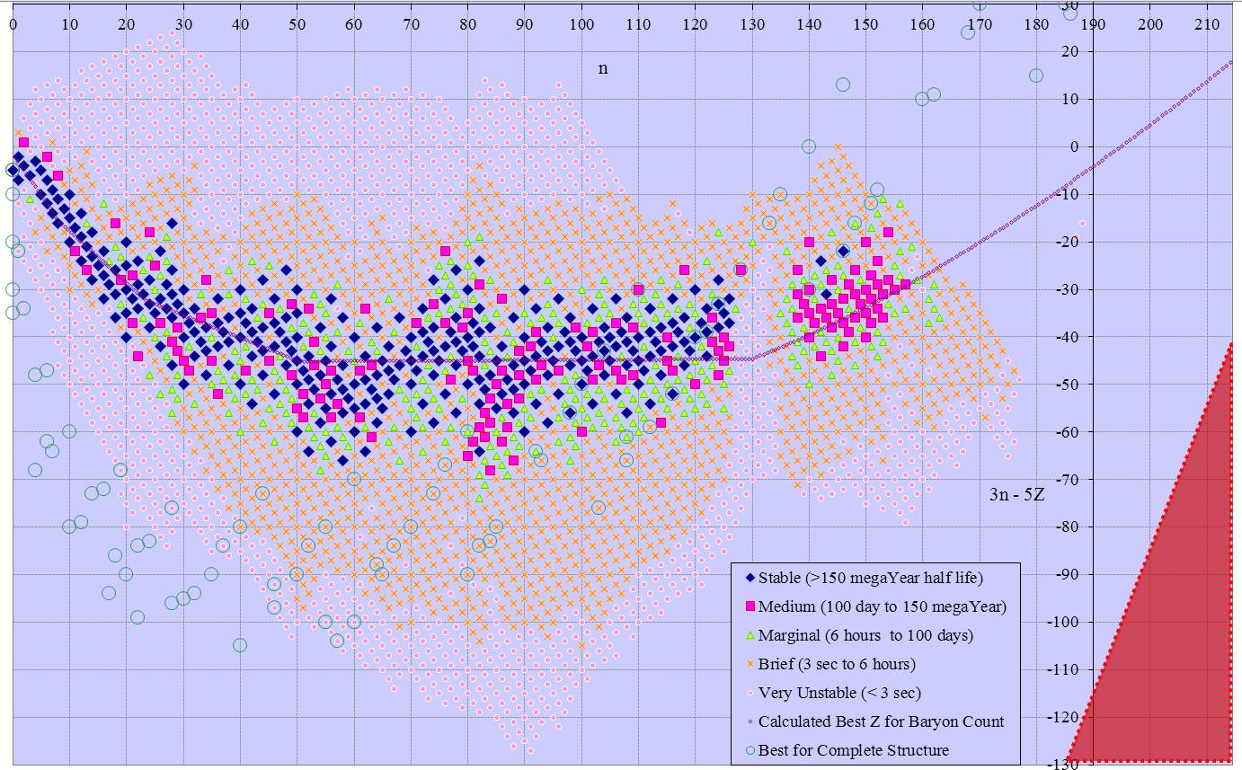

Z x N-Z
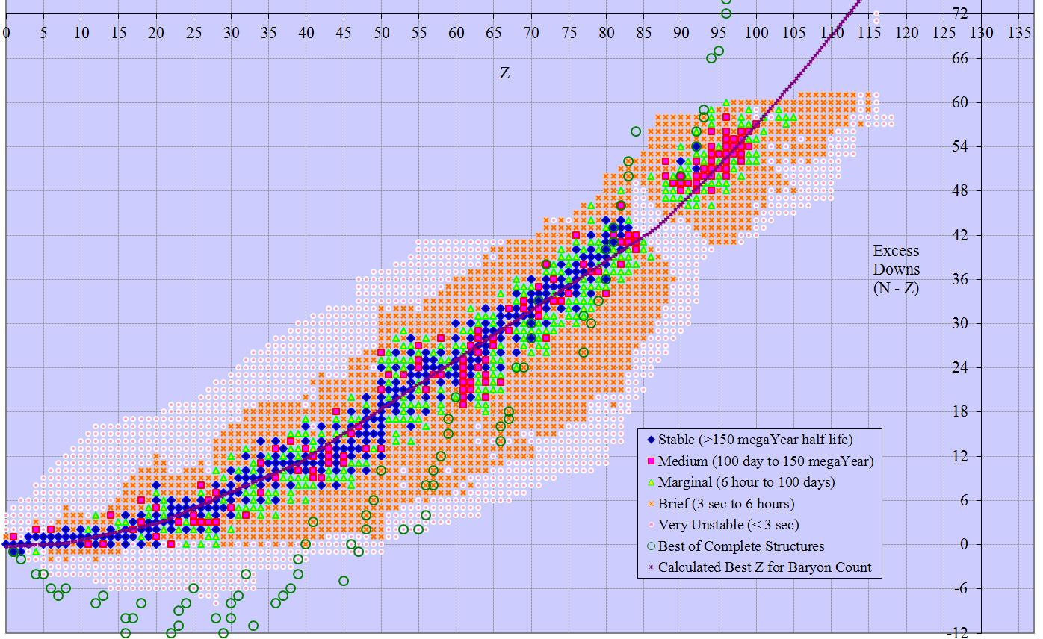

Z x N-2Z
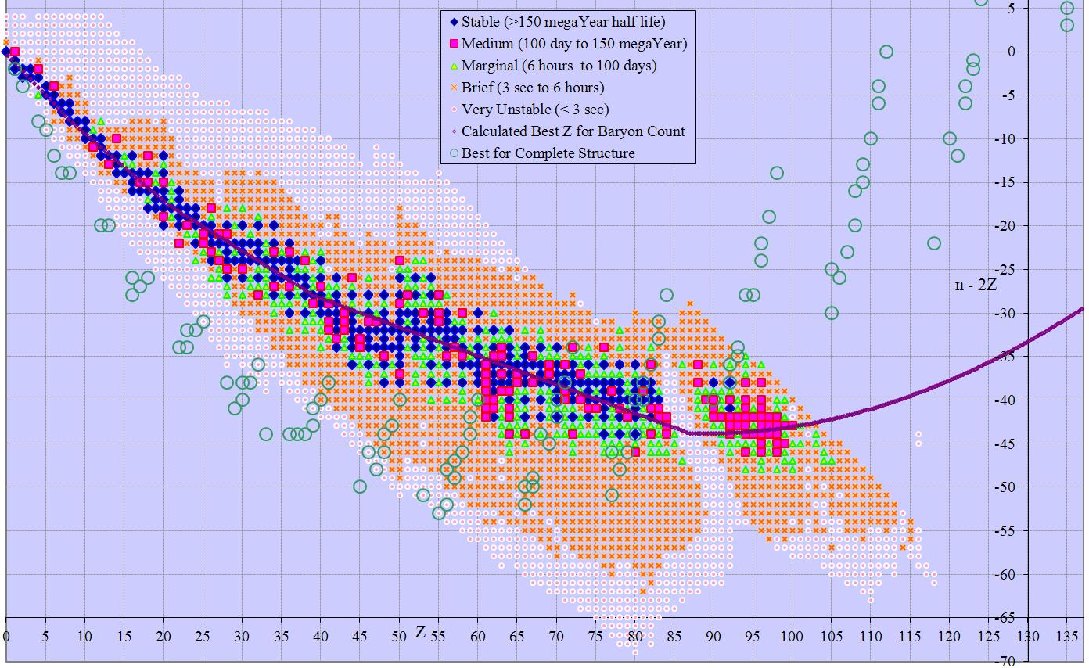

Z x 2N-3Z
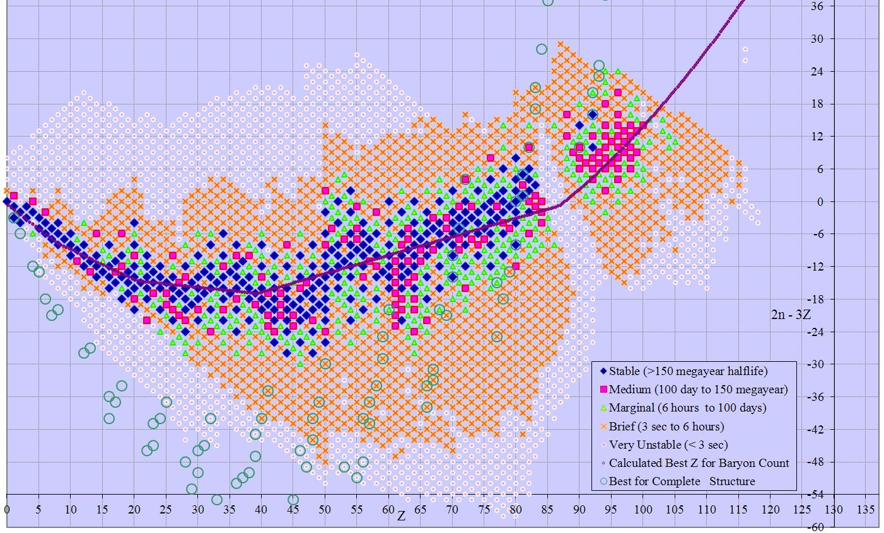

Z x 3N-5Z
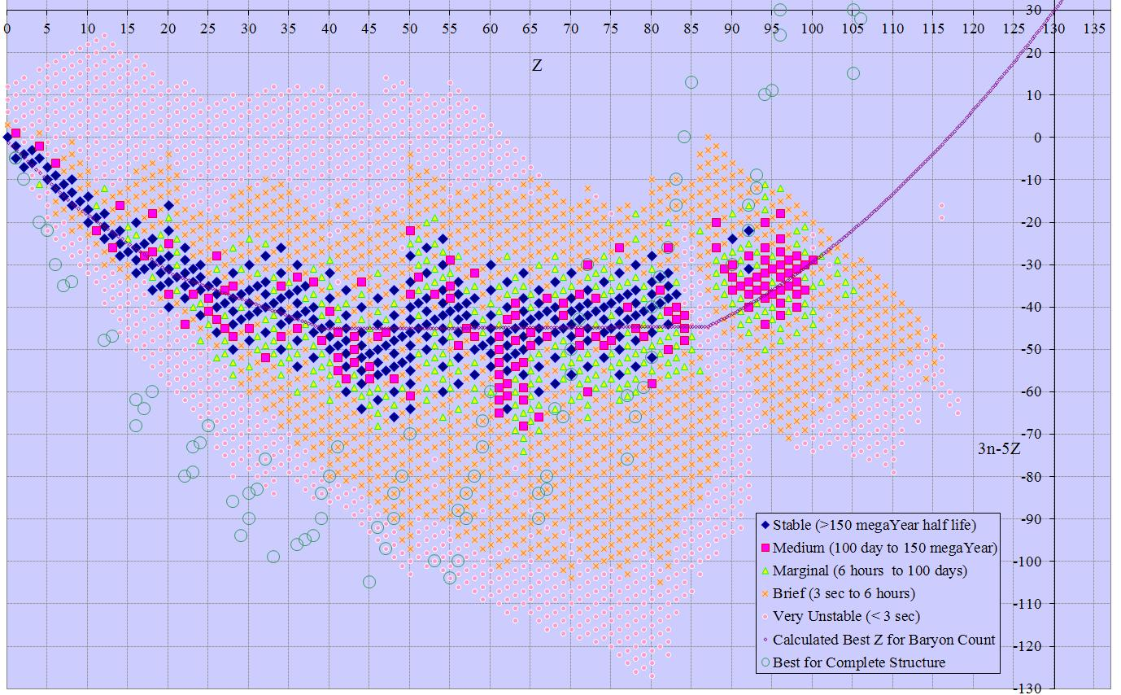

N+Z x N-Z
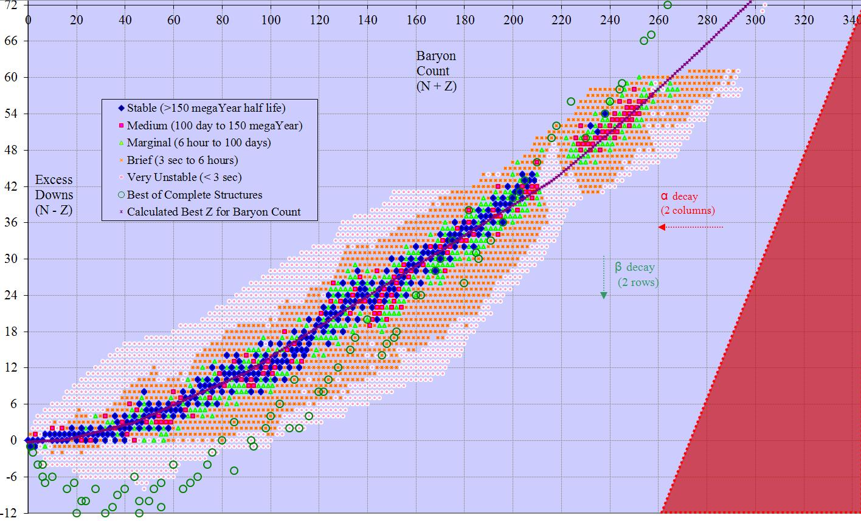

N+Z x N-2Z
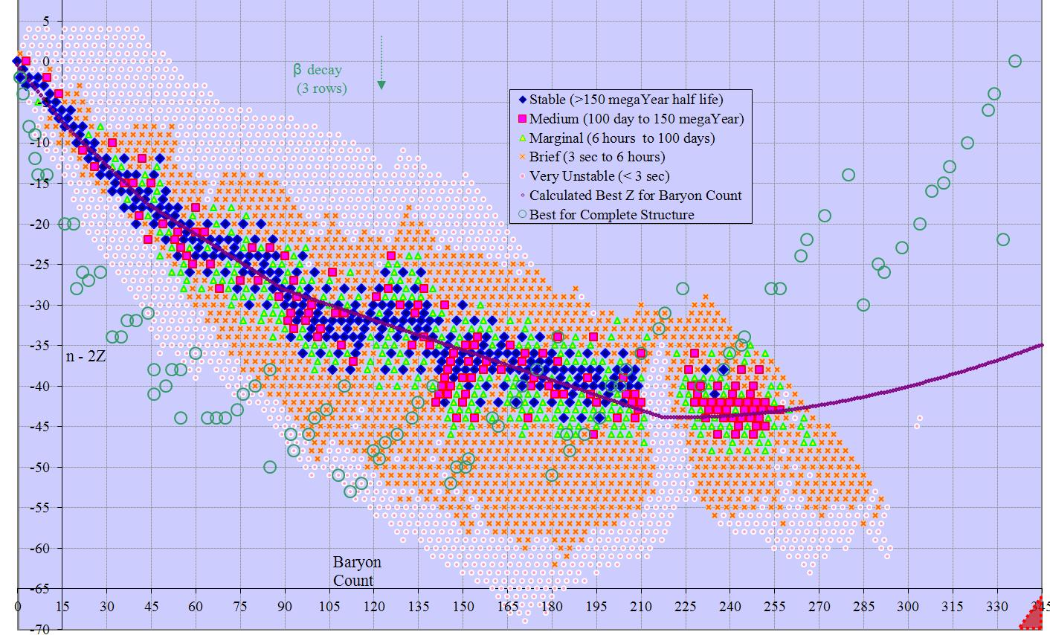

N+Z x 2N-3Z
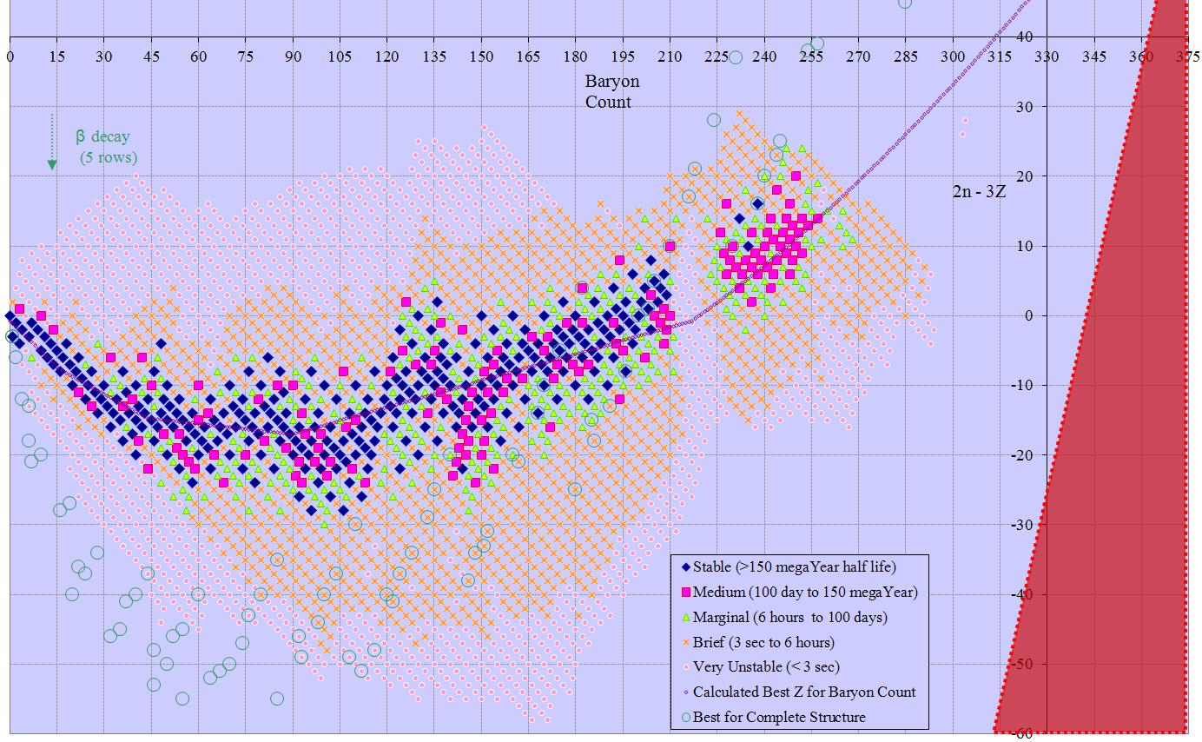

N+Z x 3N-5Z
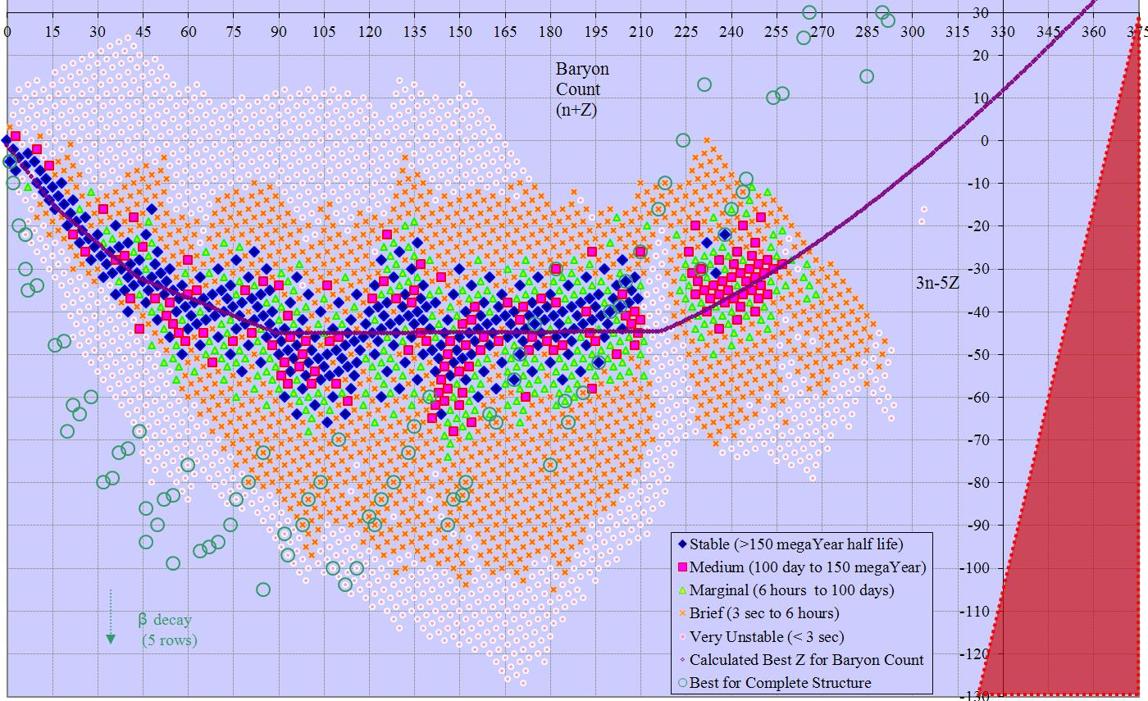

2N-3Z x N-Z
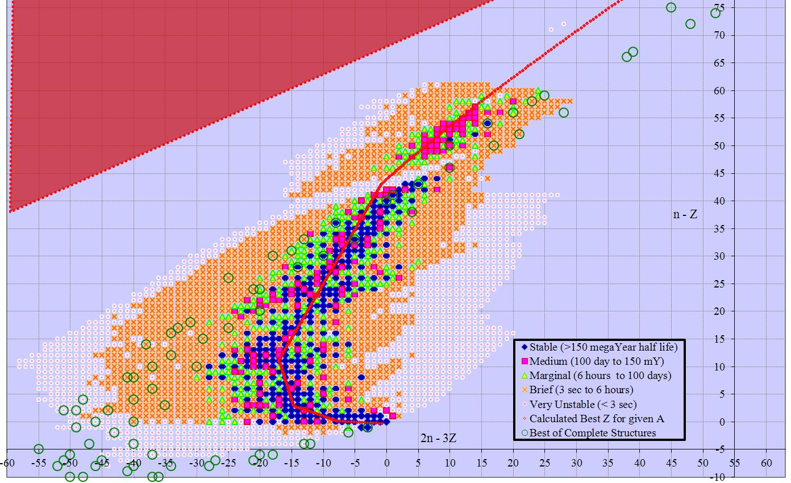

N-Z x 3N-5Z
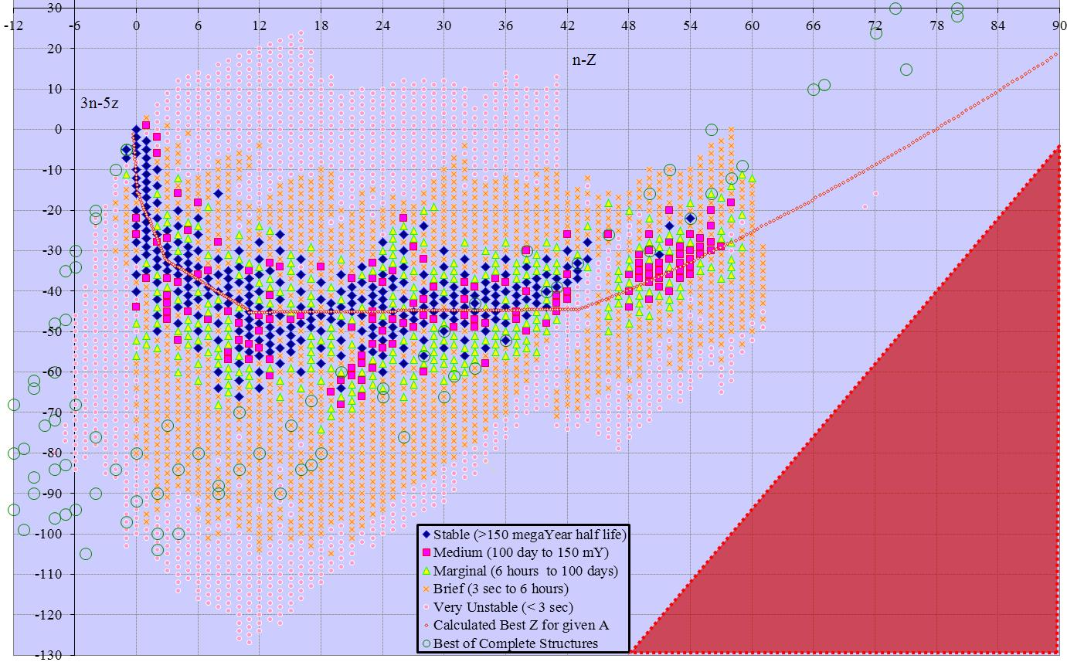

2N-3Z x N-2Z
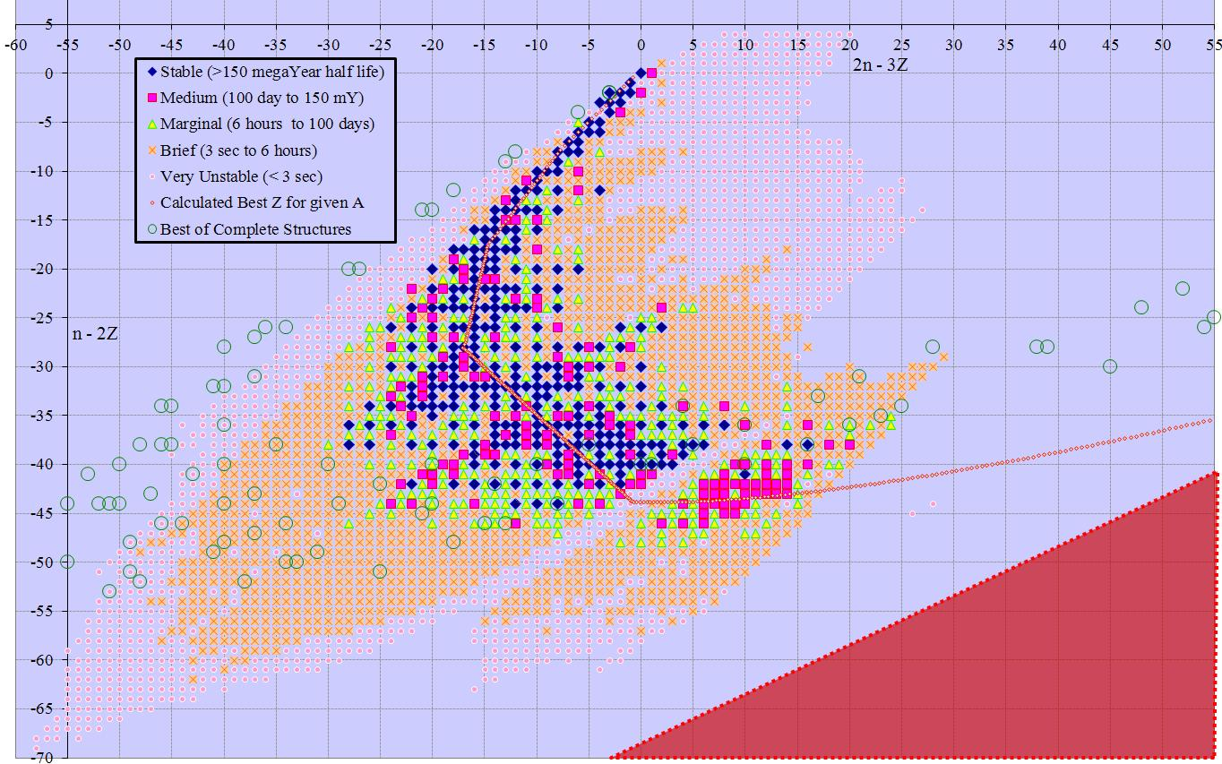

3N-5Z x N-2Z
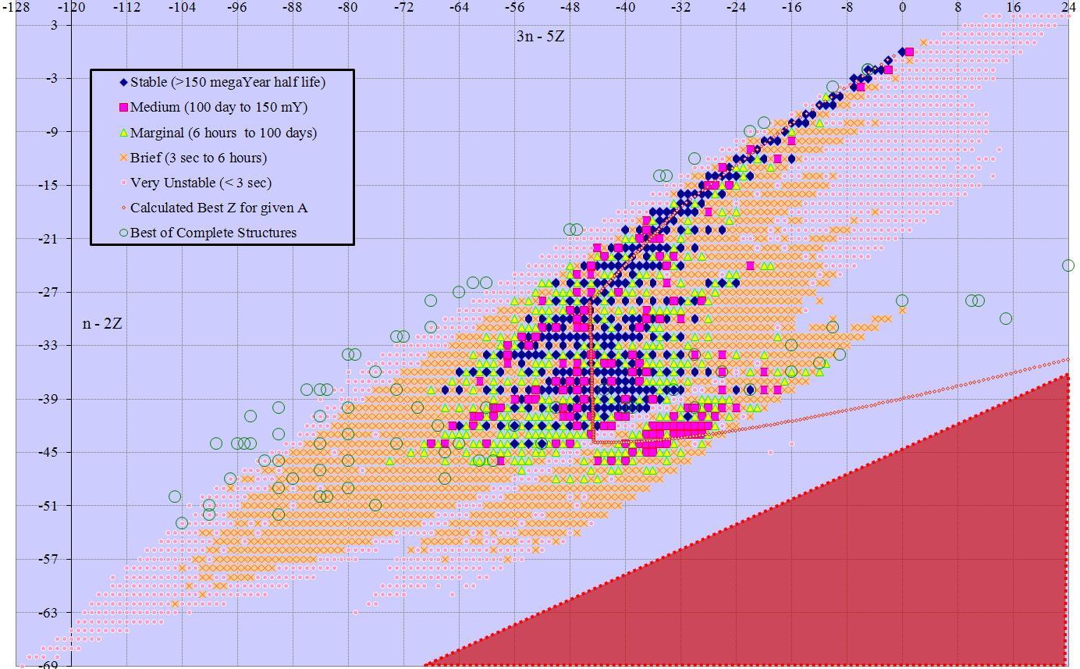

3N-5Z x 2N-3Z
