An Alternative view of Nuclear Energy
Aran David Stubbs
While it has been a long-standing convention to calculate the energy of isotopes based on how much energy would be released by merging n neutrons and z protons to form the atom, this does not jibe with the actual initial conditions. The early universe had a large quantity of hydrogen gas, which is basically a proton and an electron, and trivial amounts of other nuclei which contained neutrons.
A better alternative is to determine the energy content of the nuclei as a group of baryons and find the energy per baryon. An immediate problem arises due to lack of accurate data about nuclear mass. A large quantity of data has been generated about atomic mass – and almost all the isotopes have such data – but that includes the masking values of electrons orbiting the nucleus.
A method of getting around this is to estimate the energy content of the electrons and subtract that from the total energy content of the atom. For the small isotopes that can be done. However the total energy content of the electrons in large isotopes is not readily available. Since the total energy content of the electrons is primarily the rest mass of the electrons, a reasonable approximation can be done by assuming some value for the kinetic energy of the electrons.
The simplest method is to use a reasonable model of electron energy and test against known values. In this case the Bohr model is sufficient. Kinetic energy of the inner electrons of the heaviest known elements is less than half the mass equivalent. Using a simple formula, a reasonable approximation can be generated: the energy of electrons in shell n each have 13.606 eV *(z-(electrons in shells <n)-(half the electrons in shell n))².
The results from this method differ at the margin from results generated using the conventional method. In this case Iron-56 is the lowest energy nuclei, easily beating Nickel 62. In general, those with a low neutron fraction improved their ranking, while those with a high neutron fraction dropped. The lowest energy nuclei (those with less than 930.25 MeV per baryon) are shown below.
(Note – first set of columns is alphabetic by element name, second set is numeric by baryon count, third set is by energy per baryon. Each relevant isotope occurs in all 3 sets.)

Chromium | 50 | 930.24312 |  | Titanium | 48 | 930.24929 |  | Iron | 56 | 930.17407
Chromium | 51 | 930.24433 |  | Titanium | 50 | 930.24030 |  | Nickel | 60 | 930.18050
Chromium | 52 | 930.19205 |  | Chromium | 50 | 930.24312 |  | Nickel | 62 | 930.18620
Chromium | 53 | 930.21911 |  | Vanadium | 51 | 930.23963 |  | Chromium | 52 | 930.19205
Chromium | 54 | 930.21220 |  | Chromium | 51 | 930.24433 |  | Iron | 58 | 930.19289
Cobalt | 56 | 930.24643 |  | Chromium | 52 | 930.19205 |  | Iron | 57 | 930.20468
Cobalt | 57 | 930.21034 |  | Chromium | 53 | 930.21911 |  | Cobalt | 59 | 930.20497
Cobalt | 58 | 930.22382 |  | Manganese | 53 | 930.22069 |  | Iron | 54 | 930.20579
Cobalt | 59 | 930.20497 |  | Iron | 54 | 930.20579 |  | Nickel | 61 | 930.20615
Cobalt | 60 | 930.23611 |  | Chromium | 54 | 930.21220 |  | Iron | 55 | 930.20690
Cobalt | 61 | 930.23625 |  | Manganese | 54 | 930.22820 |  | Nickel | 58 | 930.20839
Copper | 61 | 930.23441 |  | Iron | 55 | 930.20690 |  | Cobalt | 57 | 930.21034
Copper | 62 | 930.24160 |  | Manganese | 55 | 930.21203 |  | Manganese | 55 | 930.21203
Copper | 63 | 930.21732 |  | Iron | 56 | 930.17407 |  | Chromium | 54 | 930.21220
Copper | 64 | 930.23970 |  | Cobalt | 56 | 930.24643 |  | Nickel | 59 | 930.21445
Copper | 65 | 930.23069 |  | Manganese | 56 | 930.24923 |  | Zinc | 66 | 930.21727
Iron | 54 | 930.20579 |  | Iron | 57 | 930.20468 |  | Copper | 63 | 930.21732
Iron | 55 | 930.20690 |  | Cobalt | 57 | 930.21034 |  | Chromium | 53 | 930.21911
Iron | 56 | 930.17407 |  | Iron | 58 | 930.19289 |  | Manganese | 53 | 930.22069
Iron | 57 | 930.20468 |  | Nickel | 58 | 930.20839 |  | Nickel | 64 | 930.22155
Iron | 58 | 930.19289 |  | Cobalt | 58 | 930.22382 |  | Zinc | 64 | 930.22262
Iron | 59 | 930.24020 |  | Cobalt | 59 | 930.20497 |  | Cobalt | 58 | 930.22382
Iron | 60 | 930.24863 |  | Nickel | 59 | 930.21445 |  | Nickel | 63 | 930.22654
Manganese | 53 | 930.22069 |  | Iron | 59 | 930.24020 |  | Manganese | 54 | 930.22820
Manganese | 54 | 930.22820 |  | Nickel | 60 | 930.18050 |  | Copper | 65 | 930.23069
Manganese | 55 | 930.21203 |  | Cobalt | 60 | 930.23611 |  | Copper | 61 | 930.23441
Manganese | 56 | 930.24923 |  | Iron | 60 | 930.24863 |  | Cobalt | 60 | 930.23611
Nickel | 58 | 930.20839 |  | Nickel | 61 | 930.20615 |  | Cobalt | 61 | 930.23625
Nickel | 59 | 930.21445 |  | Copper | 61 | 930.23441 |  | Zinc | 68 | 930.23853
Nickel | 60 | 930.18050 |  | Cobalt | 61 | 930.23625 |  | Vanadium | 51 | 930.23963
Nickel | 61 | 930.20615 |  | Nickel | 62 | 930.18620 |  | Copper | 64 | 930.23970
Nickel | 62 | 930.18620 |  | Copper | 62 | 930.24160 |  | Iron | 59 | 930.24020
Nickel | 63 | 930.22654 |  | Copper | 63 | 930.21732 |  | Titanium | 50 | 930.24030
Nickel | 64 | 930.22155 |  | Nickel | 63 | 930.22654 |  | Copper | 62 | 930.24160
Titanium | 48 | 930.24929 |  | Nickel | 64 | 930.22155 |  | Chromium | 50 | 930.24312
Titanium | 50 | 930.24030 |  | Zinc | 64 | 930.22262 |  | Zinc | 65 | 930.24359
Vanadium | 51 | 930.23963 |  | Copper | 64 | 930.23970 |  | Chromium | 51 | 930.24433
Zinc | 64 | 930.22262 |  | Copper | 65 | 930.23069 |  | Cobalt | 56 | 930.24643
Zinc | 65 | 930.24359 |  | Zinc | 65 | 930.24359 |  | Iron | 60 | 930.24863
Zinc | 66 | 930.21727 |  | Zinc | 66 | 930.21727 |  | Manganese | 56 | 930.24923
Zinc | 68 | 930.23853 |  | Zinc | 68 | 930.23853 |  | Titanium | 48 | 930.24929
This energy mapping does have some drawbacks. In many cases capturing an electron increases the stability of the resulting nucleus while also increasing the energy per baryon, for example Iron 55 versus Manganese 55 (which is still less than a third the mismatch of the standard form). On the plus side, it provides insight into the relative long life of the heavier isotopes. Uranium 238 only has 931.493 MeV per baryon, far less than the 931.845 of Helium 4. A complete table is available online giving energy for the 3200 known isotopes. This is in n-2z (y-axis) by a/3, a useful form for such data. Lowest energy for a baryon count is outlined in blue. The 2 lowest ratios for an element are outlined in black (for even N) and then orange (odd N).
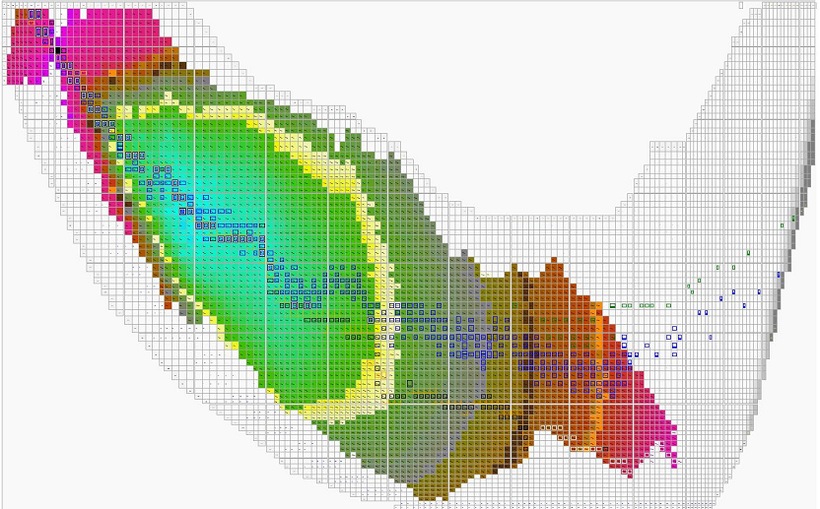
Here is a comparison between this form of the data and the binding energy per baryon classically. Sum approximates the weighted average of protons and neutrons the classic would use if the electrons effect were taken into account. It tracks closely to the ratio of neutrons to protons, with rising z a secondary effect.
Element | Weight | Energy/ Baryon | Classic Energy | Sum | N/Z
Helium | 4 | 931.84473 | 7.073915 | 938.91864 | 1.000
Nickel | 58 | 930.20839 | 8.732038 | 938.94043 | 1.071
Cobalt | 56 | 930.24643 | 8.694824 | 938.94125 | 1.074
Iron | 54 | 930.20579 | 8.736343 | 938.94213 | 1.077
Chromium | 50 | 930.24312 | 8.700981 | 938.94410 | 1.083
Copper | 61 | 930.23441 | 8.715505 | 938.94992 | 1.103
Nickel | 59 | 930.21445 | 8.736568 | 938.95102 | 1.107
Cobalt | 57 | 930.21034 | 8.741856 | 938.95220 | 1.111
Iron | 55 | 930.20690 | 8.746559 | 938.95346 | 1.115
Manganese | 53 | 930.22069 | 8.734132 | 938.95482 | 1.120
Chromium | 51 | 930.24433 | 8.711955 | 938.95628 | 1.125
Zinc | 64 | 930.22262 | 8.735897 | 938.95852 | 1.133
Copper | 62 | 930.24160 | 8.718074 | 938.95967 | 1.138
Nickel | 60 | 930.18050 | 8.780754 | 938.96125 | 1.143
Cobalt | 58 | 930.22382 | 8.738944 | 938.96276 | 1.148
Iron | 56 | 930.17407 | 8.790322 | 938.96439 | 1.154
Manganese | 54 | 930.22820 | 8.737922 | 938.96612 | 1.160
Chromium | 52 | 930.19205 | 8.775944 | 938.96799 | 1.167
Zinc | 65 | 930.24359 | 8.724257 | 938.96785 | 1.167
Copper | 63 | 930.21732 | 8.752131 | 938.96945 | 1.172
Nickel | 61 | 930.20615 | 8.765006 | 938.96998 | 1.179
Titanium | 48 | 930.24929 | 8.722905 | 938.97220 | 1.182
Cobalt | 59 | 930.20497 | 8.768010 | 938.97298 | 1.185
Iron | 57 | 930.20468 | 8.770248 | 938.97493 | 1.192
Manganese | 55 | 930.21203 | 8.764988 | 938.97702 | 1.200
Zinc | 66 | 930.21727 | 8.759631 | 938.97690 | 1.200
Copper | 64 | 930.23970 | 8.739067 | 938.97877 | 1.207
Chromium | 53 | 930.21911 | 8.760155 | 938.97926 | 1.208
Nickel | 62 | 930.18620 | 8.794546 | 938.98075 | 1.214
Vanadium | 51 | 930.23963 | 8.742051 | 938.98168 | 1.217
Cobalt | 60 | 930.23611 | 8.746742 | 938.98285 | 1.222
Iron | 58 | 930.19289 | 8.792220 | 938.98511 | 1.231
Manganese | 56 | 930.24923 | 8.738299 | 938.98753 | 1.240
Copper | 65 | 930.23069 | 8.757094 | 938.98778 | 1.241
Chromium | 54 | 930.21220 | 8.777913 | 938.99011 | 1.250
Nickel | 63 | 930.22654 | 8.763486 | 938.99003 | 1.250
Cobalt | 61 | 930.23625 | 8.756149 | 938.99240 | 1.259
Zinc | 68 | 930.23853 | 8.755677 | 938.99421 | 1.267
Iron | 59 | 930.24020 | 8.754742 | 938.99494 | 1.269
Titanium | 50 | 930.24030 | 8.755621 | 938.99592 | 1.273
Nickel | 64 | 930.22155 | 8.777461 | 938.99901 | 1.286
Iron | 60 | 930.24863 | 8.755836 | 939.00447 | 1.308
Uranium | 238 | 931.49291 | 7.570120 | 939.06303 | 1.587

